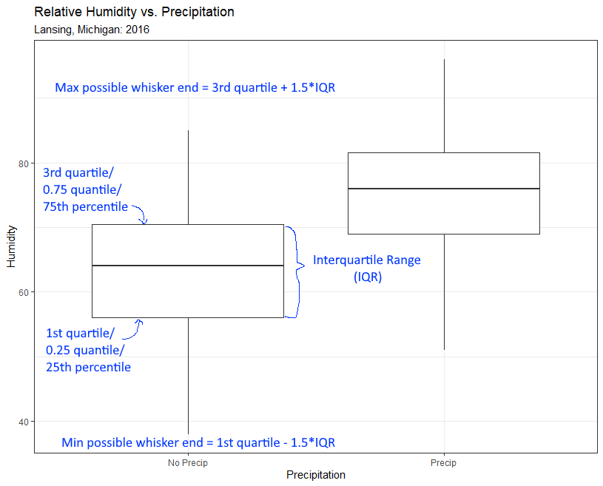

The multiplier ***1.5*** is the default value – but this is often changed to extend or contract the whiskers (in ***geom_boxplot()*** it is the subcomponent ***coef***).

The min and max possible whiskers ends are (usually) not the actual whisker ends. The **actual whisker end** is the data point with the closest value to the possible whisker end without going beyond.